**EXPERIMENT:3 Create a simple cloud software application for Car Booking Reservation System using any Cloud Service Provider to demonstrate SaaS include the necessary fields such as search for cabs, from, to, rental , out station, Package type, hours/Days etc.**

**AIM:** To create a simple cloud software application for Car Booking Reservation System using any Cloud Service Provider to demonstrate SaaS.

**PROCEDURE**:

**step1**: Go to zoho.com

**step 2:** Log into the zoho.com.

**step 3:** Select one application step.

**step4:** Enter application name as Car Booking Reservation System.

**step 5:** Created new application as Car Booking Reservation System.

**step 6:** Select one form

**step 7:** The software has been created.

**IMPLEMENTATION:**

**Login page**

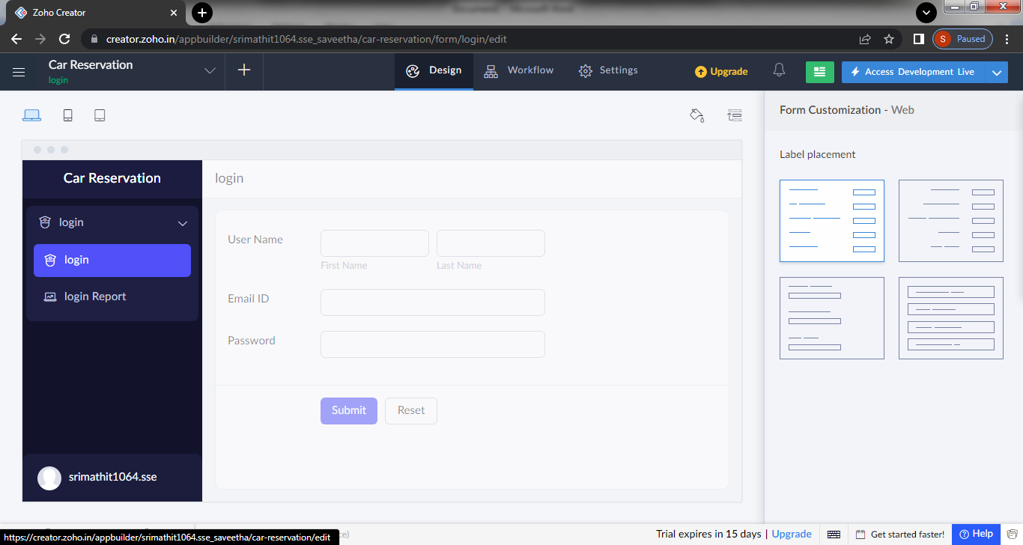

**Verification page**

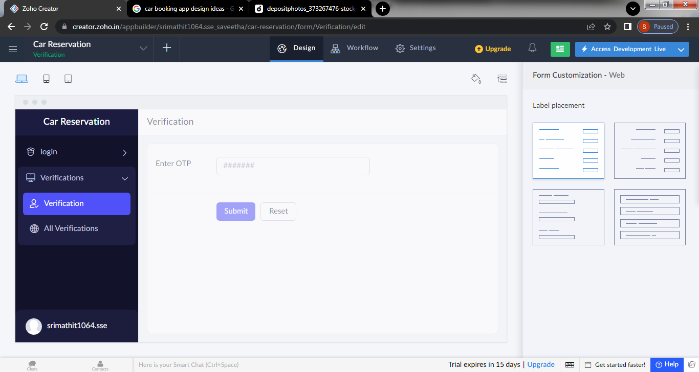

**Book a cab**

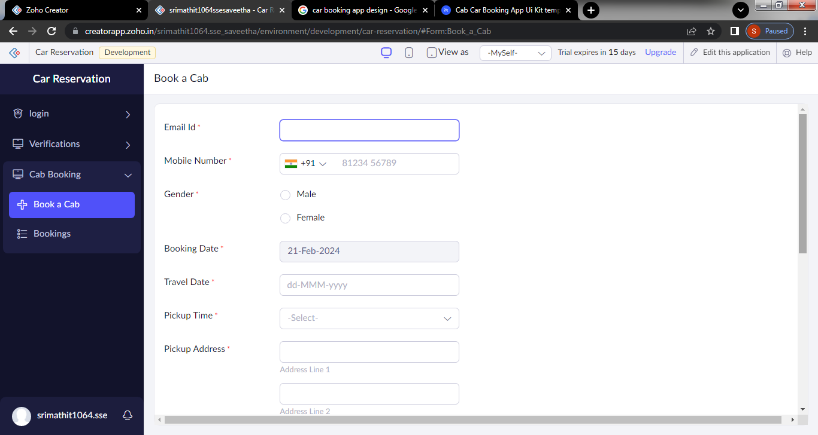

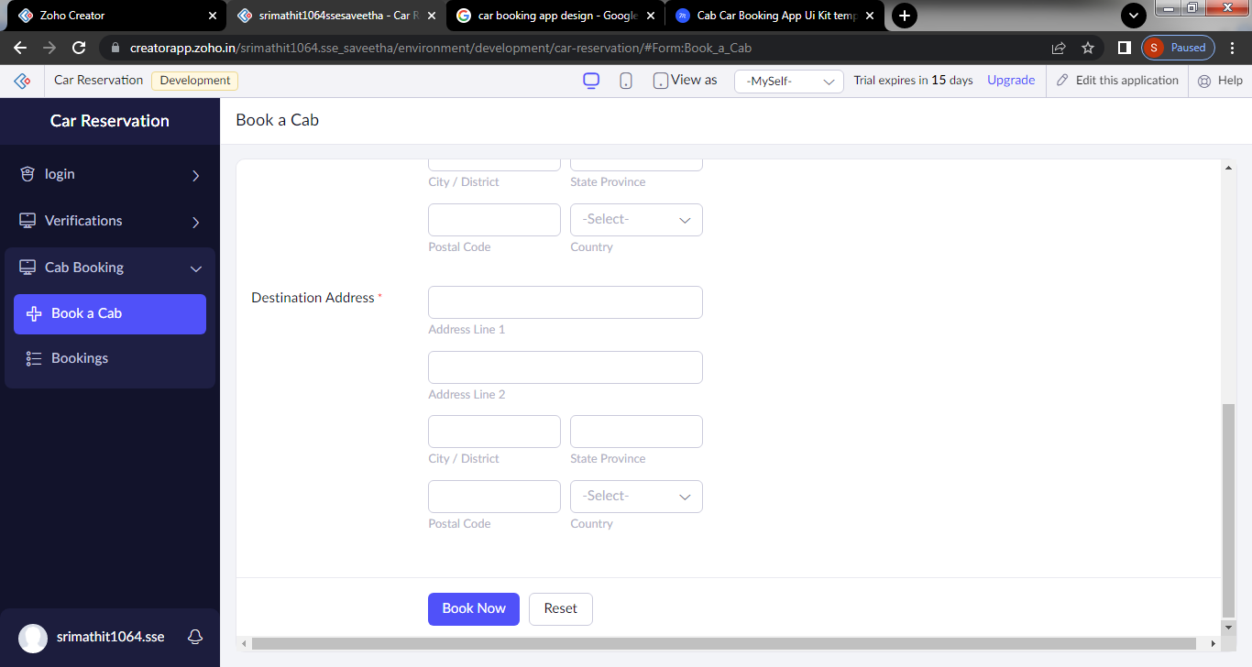

**Payment**

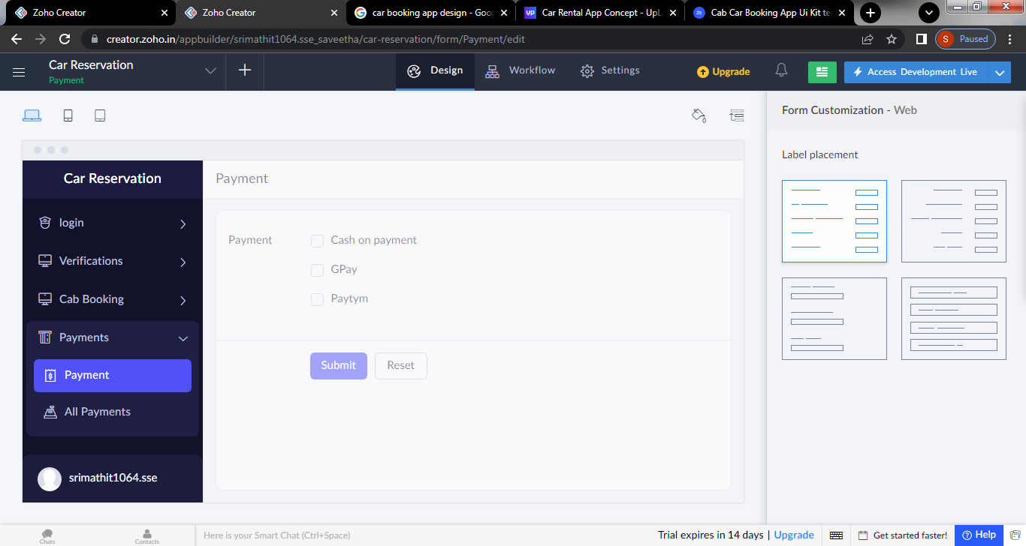

**Mobile view of the software**

